Pulling twitter data from its REST API
- Overview
In the SMILE application, we have implemented two different searching methods: Searching the content (tweet) by keywords with a set of parameters, and searching the user account by keywords and other parameters. We offer a user-friendly interface to facilitate the searching task, while behind the veil, a GraphQL based data server is handling the heavy lifting of interacting with Twitter's API.

User
Search Interface
(Analytics Server)
Twitter API
GraphQL server
Query
Data

Figure 1. The workflow of pulling data from Twitter

GraphQL is a query language for APIs that can full fill queries with any existing data source. In the SMILE application, GraphQL serves as a “middle man” that takes queries from the user, assembles the requests and sends them off to Twitter. Twitter’s API provides a way to programmatically access to data from its database using application credentials plus each user’s own credentials. Once Twitter has received and validated those requests, data will be returned back correspondingly. GraphQL server then formats those data to a pre-designed schema and send them back to the analytics server in a JSON format. Analytics server is able to utilize these data for the following computing tasks, as well as be able to convert the data into a tabular format (.csv) that enables downloading.

- Authentication and Authorization
The first time user enters the search page, an authorization must be performed by the user to grant the SMILE application the permission to requesting data from Twitter on user's behalf. After clicking the button, SMILE will redirect the user to the Twitter’s authorize page where it asks for username and password. Once you hit the "Authorize app" button, you have successfully fulfilled the process and will be redirected back to the SMILE search page. This process follows a generic 3-legged OAuth flow practice.
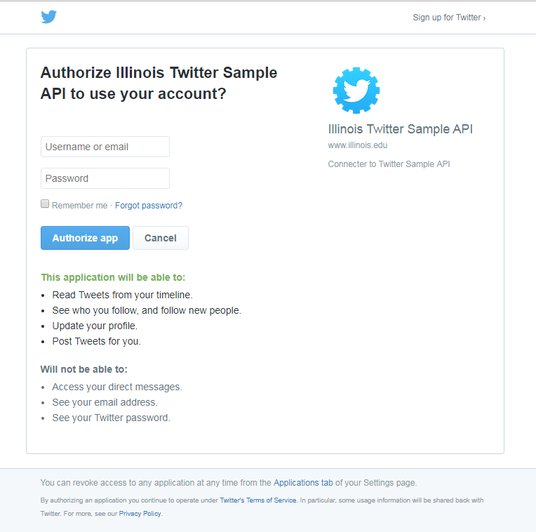
1
2
3
Figure 2. The authorization process in the SMILE application
OAuth (Open Authorization) is an open protocol for token-based authentication and authorization on the internet. It allows an end user's account information to be used by third-party services (here: SMILE), without actually exposing the user's password to that services. A 3-legged OAuth flow is illustrated below (Figure 3). The main idea behind this is: twitter or any social media service will grant the application certain access token which allows the application to act on behalf of the user. The SMILE application intends to attain this access token, pass it to the GraphQL data server, and send this access token along with user's request to Twitter in order to fetch data.
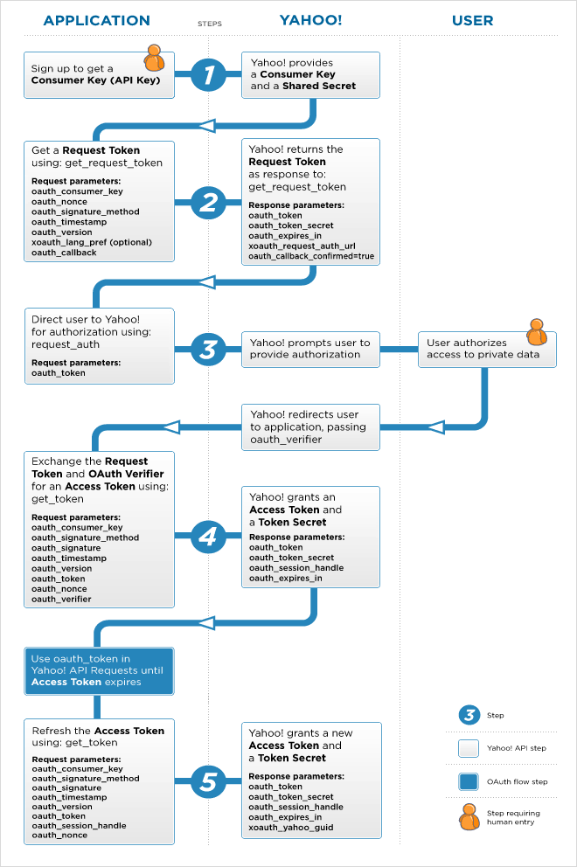
Twitter
SMILE
Twitter
Twitter
Twitter
Twitter
Twitter
Twitter
Twitter
Twitter
Twitter

Figure 3. Three-legged OAuth Flow

- Search Tweets
The Twitter Search API, which is essentially the endpoint of https://api.twitter.com/1.1/search/tweets.json, will return a collection of relevant Tweets matching a specific query. The searches will be performed against a sampling of recent Tweets published in the past 7 days. The default setting only return the maximum number of 1,800 tweets that match user's query, while there are other parameters to make the search more accurate. When you hit the  button, a dropdown list will appear with the following options:
- English keyword, phrases, numbers, operators, and any combination of them that are no longer than 500 characters. This is corresponding to the “q” parameter of the endpoint.
- The maximum number of tweets (Note: the maximum number of matches will be returned). This will be translated to Twitter’s fashion of pagination, i.e. “count”, “since_id” and “max_id” parameters.
- Date Range of the search results can be selected by the user, with the starting date fixed as 7 days in the past, and an end date of user’s choice. This is the “until” parameter.
- You can search within an area on the map if you can provide the latitude, longitude as well as the radius of miles. These are corresponding to the “geocode” parameter.
- You can decide what fields you want in the return data. For example, some user might only want tweet “text” and others might only want the “id” of the tweet.

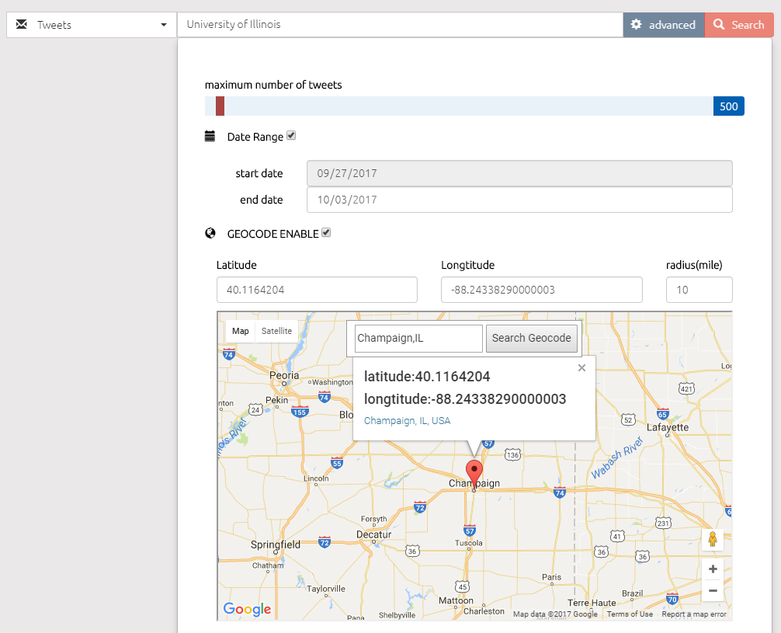
Select a data source
Keywords for query
Move the slider to set a maximum number of tweets
Date range with a fixed start date of 7 days ago
Set an end date here
Use Google map get geocode
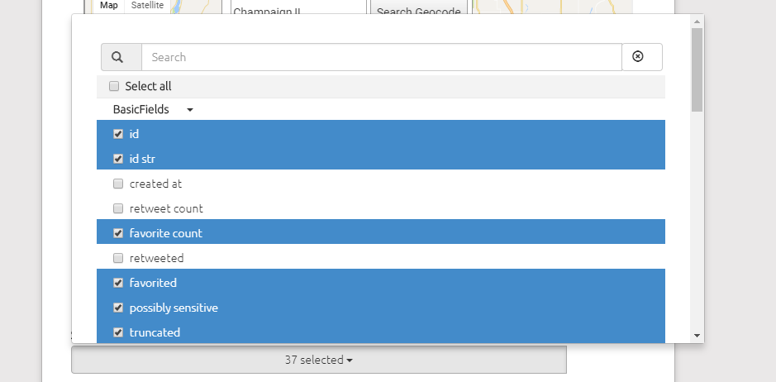
Select the fields you want
Figure 4. The advanced setting of the search interface of the SMILE
It is important to know that the Search API is focused on relevance and not completeness. This means that some Tweets and users may be missing from search results. If you want to match for completeness you should consider searching against our archived streaming tweets.

Another thing worth noticing is, if you set the maximum number of tweets to a big number, you’re risking to have rate limiting. Twitter’s rate limiting policy determines that a maximum of 180 requests can be sent in any 15-minutes window. For each request, the maximum number of returned tweets is 100. In another word, you can only get 100 × 180 = 18000 tweets every 15 minutes. An error will appear and you will not be able to get any data if you reach this rate limit.

- Search Users
The endpoint https://api.twitter.com/1.1/users/search.json provides a simple, relevance-based search to public user accounts on Twitter. Try querying by topical interest, full name, company name, location, or other criteria. Exact match searches are not supported. Only the first 1,000 matching results are available.
When you hit the  button, a dropdown list will appear with the following options:
- The search query to run against people search should be consist of English keyword, phrases, numbers, and any combination of them. This is corresponding to the “q” parameter.
- The maximum number of users (Note: the maximum number of matches will be returned.) This will be translated into Twitter’s fashion of pagination, i.e. “page” and “count” parameters. Only the first 1,000 matching results are available.
- Date Range of the search results can be selected by the user, with the starting date fixed as 7 days ago and an end date of user’s choice. This is the “until” parameter.
- You can decide what fields you need in the returned data. For example, some user might only want the “author id” and others might want the “screen_name” as well as the “description”.

- Data aggregation, storage, and distribution
After acquiring the data from Twitter, the analytics server will parse the JSON format data from Twitter into a human-readable CSV file which is compatible with excel and any generic text editor. The structure of the CSV file is quite self-explanatory. The header row is the field/label, for example: “text”, “created_at”, “id”, “user.location” and etc., and each row is one tweet. The CSV file will be named by the user, and stored in the corresponding session folder of user’s home directory on the socialmediamacroscope.org. Due to the security concerns, direct access to the session folder is only for the website administrators and application developers, but not to the end user. However, an in-situ (in-page) download is available, meanwhile, the past search results can be found on the history page.
Once you click the button, a popup modal that prompts you to name the CSV file will show up. Keep in mind that a legal filename should only include alphabet, number, underscore and dash; please don’t include the file extension. If you have already named another file using the same name in the same session, an alert will appear to remind you to rename the file (Figure 5).
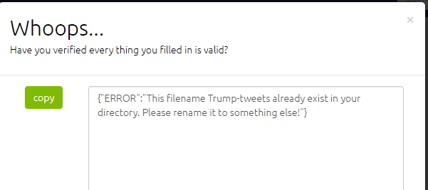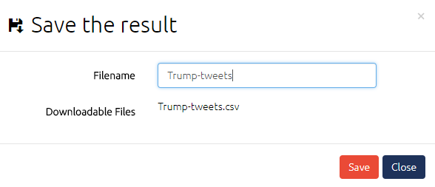
Figure 5. Saving the search result
If the query has performed successfully, you will see a download modal popping up with a “DOWNLOAD XXXXX.csv” link. You’ll have the access and the ownership of this twitter data. Whatever you would like to do with this CSV file after downloading is out of the scope of this documentation; however, it is just a reminder to you that publically sharing the data violates Twitter's terms of use.
If you have accidentally left the search page and would like to get back to your previous search results, a history page is available for that purpose. All the SMILE generated data in the same session can be found on this page. First, the user should click the “History” button on the top bar, then on the left panel expand “Social Media Data” “Twitter Tweet” (for example) “view”. In the “Overview” part of that data in the right panel, there’s a link in the “downloadables” column that will lead you to the CSV file (Figure 6).

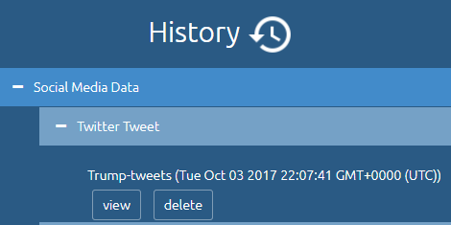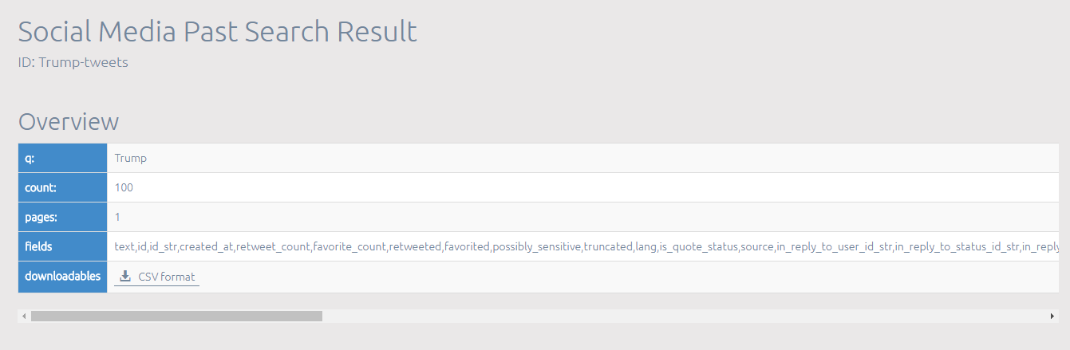
Figure 6. Find past search results in the history page
- A Short Introduction of GraphQL – the next generation API language
GraphQL is an application layer query language that developed by Facebook and later open-sourced to the community. In GraphQL, the schema of the resources is pre-defined, as well as the queries and mutations you can perform on those resources. Hence, it can easily interpret a string from a server or client, and return that data in an understandable, stable, and predictable format. As the official website for GraphQL puts it, “Describe your data, ask for what you want, get predictable results.”
GraphQL is used in the SMILE application as the underlying data server. We chose GraphQL as the query language for a few reasons:
- It is versatile with different data sources, database, and storage engines. In another word, it can be backed by any source of existing data. In the SMILE application, so far we have three data sources, two of them comes from Twitter's API and the third is the archived tweets in our AWS elasticsearch database. In the future, we plan to add more sources such as different social media platforms and different archives hosting by various institutions.
- In contrast to REST APIs which expose a suite of URLs each of which exposes a single resource, GraphQL provides a single endpoint which expresses the full set of capabilities of the service. With an increased number of resources we would like to include in our application, a single and central endpoint to serve data over HTTP is immensely helpful.
- The client can define explicit interest on specific attributes of specific resources to retrieve when querying. And the returning results are in conformity with the structure of your query. For example, the user can specify that they only want “text”, ”created_at”, “id” fields when searching for tweets, and other redundant fields such as “author id”, “author_screen_name” will not show up. Another example is showed in Figure 7. The left panel is the query, and the right panel is the returned data.
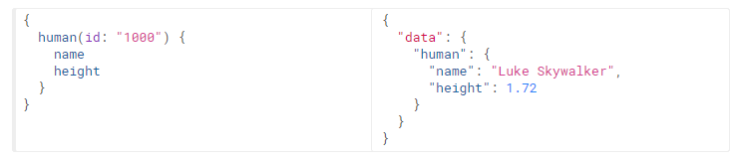
Figure 7. An example of GraphQL query and result

https://developer.twitter.com/en/docs
Note: Twitter's API follows a REST design. REST stands for Representational State Transfer which is a web architecture
http://graphql.org/
JSON (JavaScript Object Notation) is a lightweight data-interchange format. It is easy for humans to read and write. It is easy for machines to parse and generate.
https://oauth.net/2/
https://developer.twitter.com/en/docs/tweets/search/api-reference/get-search-tweets.html
https://developer.twitter.com/en/docs/basics/rate-limiting
https://developer.twitter.com/en/docs/accounts-and-users/follow-search-get-users/api-reference/get-users-search

